Part 1: TITLE, AUTHORS, APPROVALS, etc

Code assigned: | 2022.017M
Short title: Create a new species in genus Orthobunyavirus (Bunyavirales: Peribunyaviridae)
Author(s) and email address(es)
Zhao L, Liu R, Zhang G, Yuan Z, Xia H | luzhaowiv@qq.com;  liuran_aqua@aliyun.com; 1920473941@qq.com; yzm@wh.iov.cn; hanxia@wh.iov.cn
Author(s) institutional address(es) (optional)
Wuhan Institute of Virology, CAS, China (LZ, ZY, HX)
Center for Disease Control and Prevention of Xinjiang Uygur Autonomous Region, Urumqi, China (RL, GZ)
Corresponding author
Xia H
List the ICTV Study Group(s) that have seen this proposal
ICTV Peribunyaviridae Study Group
ICTV Study Group comments and response of proposer

Approved.
ICTV Study Group votes on proposal

Study Group | Number of members
 | Votes support | Votes against | No vote
ICTV Peribunyaviridae Study Group | 8 | 0 | 1
Authority to use the name of a living person

Is any taxon name used here derived from that of a living person (Y/N) | N

Taxon name | Person from whom the name is derived | Permission attached (Y/N)

Submission dates
Date first submitted to SC Chair | May 27, 2022
Date of this revision (if different to above)
ICTV-EC comments and response of the proposer

Part 3: TAXONOMIC PROPOSAL
Name of accompanying Excel module
2022.017M.N.v1.Orthobunyavirus_1nsp.xlsx
Abstract
The family Peribunyaviridae includes four genera: Herbevirus, Orthobunyavirus, Pacuvirus
and Shangavirus. Here we propose to create one new species in genus Orthobunyavirus for Ebinur Lake virus.
Text of proposal
Ebinur Lake virus (EBIV) isolate Cu20-XJ was originally isolated from Culex modestus Ficalbi, 1889 mosquitoes in 2013 in Xinjiang Province, China [1]. Mature spherical, enveloped virions of approximately 90–100 nm in diameter were detected in pellets generated by ultracentrifugation of EBIV-infected BHK-21 cell culture supernatants, which were structurally similar to those of other members of the genus Orthobunyavirus.
The full-length large (L) segment sequence (GenBank #KJ710425) of EBIV is 6,799 nucleotides long encoding a predicted large (L) protein including a RNA-directed RNA polymerase (RdRp) domain of 2,238 amino acids, starting at nucleotide position 47 and including 36 nucleotides of the 3′ noncoding region. The entire medium (M) segment sequence (GenBank #KJ710423) of EBIV is 4,422 nucleotides long encoding a predicted glycoprotein (GP) precursor of 1,435 amino acids. The full-length small (S) segment sequence (GenBank #KJ710424) of EBIV is 973 nucleotides long encoding a predicted nucleoprotein (NP) of 233 amino acids (Table 1).
The phylogenetic results of all three segments demonstrate that EBIV belongs to the peribunyaviral genus Orthobunyavirus and clusters with the members of the Bunyamwera serogroup (Figure 1A–C). The nucleotide identity analysis matrix, based on the selected viruses, indicates that the S segment has the highest identity, whereas the M segment has the lowest identity within the Bunyamwera serogroup. The S, M, and L segments of EBIV share the highest sequence similarity with those of Germiston virus (90.7%), Germiston virus (77.3%), and Bunyamwera virus (72.7%), respectively (Figure 1D–F). Amino acid similarity analysis indicated that the amino acid sequences of NP and GP of EBIV have the highest similarity with Germiston virus at 95.7% and 89.0%. In addition, the L segment amino acid identity is less than 96% when compared to other orthobunyaviruses (Table 2).
EBIV can replicated efficiently and cause cytopathic effects (CPEs) in invertebrate and vertebrate cells. EBIV causes severe disease and even death in exposed adult Kunming and BALB/c laboratory mice, and antibodies against EBIV have been detected in local residents, indicating that the virus is a potential animal or human pathogen [2, 3].
Based on the morphology of virions, phylogeny, and characteristics of the Infection in vivo and in vitro, we propose to classify EBIV as a representative of a new orthobunyaviruses species.

Supporting evidence

Table 1. Features of the CDSs encoded by Ebinur Lake virus strain Cu20-XJ

Segment | CDS | Start (nt) | Stop (nt) | Length (nt | aa)
S | NP | 86 | 787 | 702 | 234
M | GP | 53 | 4360 | 4308 | 1436
L | L | 47 | 6763 | 6717 | 2239

Table 2. L segment amino acid identity matrix of representative orthobunyaviruses (%).
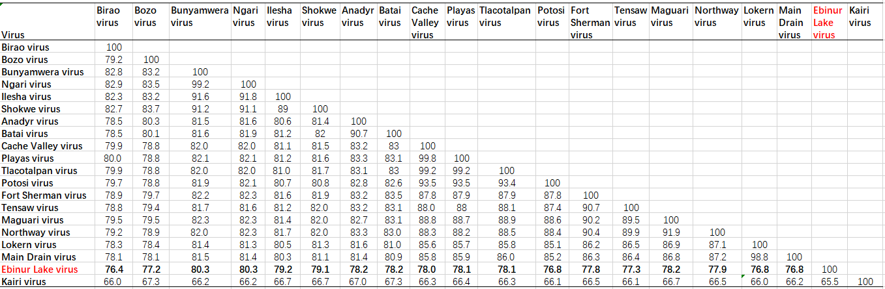
Figure 1. Maximum likelihood phylogenetic trees (A–C) and pairwise distance (D–F) based on alignments of nucleotide sequences of orthobunyaviruses. The scale bar indicates the evolutionary distance in the number of substitutions per nucleotide substitution/site, and the principal bootstrap support levels are indicated. Branches are color coded according to group. Ebinur Lake virus is indicated by a red square, and Herbert virus (peribunyaviral genus Herbevirus) was used as an outgroup in the ML trees.

References
1. Liu R, Zhang G, Yang Y, Dang R, Zhao T (2014) Genome sequence of abbey lake virus, a novel orthobunyavirus isolated from china. Genome Announc 2. PMID: 24948753. PMCID: PMC4064019. doi: 10.1128/genomeA.00433-14.
2. Xia H, Liu R, Zhao L, Sun X, Zheng Z, Atoni E, Hu X, Zhang B, Zhang G, Yuan Z (2019) Characterization of Ebinur Lake Virus and Its Human Seroprevalence at the China-Kazakhstan Border. Front Microbiol 10:3111. PMID: 32082268. PMCID: PMC7002386. doi: 10.3389/fmicb.2019.03111.
3. Zhao L, Luo H, Huang D, Yu P, Dong Q, Mwaliko C, Atoni E, Nyaruaba R, Yuan J, Zhang G, Bente D, Yuan Z, Xia H (2020) Pathogenesis and Immune Response of Ebinur Lake Virus: A Newly Identified Orthobunyavirus That Exhibited Strong Virulence in Mice. Front Microbiol 11:625661. PMID: 33597934. PMCID: PMC7882632. doi: 10.3389/fmicb.2020.625661.

