Part 1: TITLE, AUTHORS, APPROVALS, etc

Code assigned: | 2022.015M
Short title: Four new species in family Nairoviridae (Bunyavirales)
Author(s) and email address(es)
Alkhovsky SV, Avšič-Županc T, Bergeron É, Burt F, Ergünay K, Garrison AR, Kuhn JH, Marklewitz M, Mirazimi A, Papa A, Pawęska JT, Spengler JR, Palacios G | salkh@yandex.ru; Tatjana.Avsic@mf.uni-lj.si; exj8@cdc.gov; burtfj@ufs.ac.za; ekoray@hacettepe.edu.tr; aura.r.garrison.civ@mail.mil; kuhnjens@mail.nih.gov; marklewitz.ictv@gmx.de; Ali.Mirazimi@ki.se; annap.med@gmail.com; januszp@nicd.ac.za; wsk7@cdc.gov; gustavo.palacios@mssm.edu
Author(s) institutional address(es) (optional)
Corresponding author
Palacios G
List the ICTV Study Group(s) that have seen this proposal
ICTV Nairoviridae Study Group
ICTV Study Group comments and response of proposer
Approved.
ICTV Study Group votes on proposal
Study Group | Number of members
 | Votes support | Votes against | No vote
ICTV Nairoviridae Study Group | 13 | 0 | 0
Authority to use the name of a living person
Is any taxon name used here derived from that of a living person (Y/N) | N

Taxon name | Person from whom the name is derived | Permission attached (Y/N)
Submission dates
Date first submitted to SC Chair | May 27, 2022
Date of this revision (if different to above)
ICTV-EC comments and response of the proposer

Part 2: NON-TAXONOMIC PROPOSAL
Text of proposal

Part 3: TAXONOMIC PROPOSAL
Name of accompanying Excel module
2022.015M.N.v1.Nairoviridae_4nsp.xlsx
Abstract
We propose the classification of three novel orthonairoviruses (Sōnglǐng virus, Sulina virus, and Yezo virus) and one novel norwavirus (Běijí nairovirus) into four novel nairovirid species.
Text of proposal
The bunyaviral family Nairoviridae currently includes six monospecific genera (Norwavirus, Ocetevirus, Sabavirus, Shaspivirus, Striwavirus, and Xinspivirus) and genus Orthonairovirus, which includes 41 species. In 2021, the ICTV Nairoviridae Study Group
established a species demarcation criterion of <93% identity in the amino acid sequence of the nairovirid RNA-directed RNA polymerase (RdRp) (TaxoProp 2020.027M). A reanalysis of the dataset used in TaxoProp 2020.027M, complemented with newly described nairovirid sequences, indicated four viruses should be classified into four novel species (Supplementary Data, Figure 1):

Novel norwavirus species:
Běijí nairovirus (BJNV) was first discovered by HTS in taiga ticks (ixodid Ixodes persulcatus (Schulze, 1930)) sampled in Běijí (北极镇), Hēilóngjiāng Province (黑龙江省), China [4]. Gakugsa tick virus, found in taiga ticks sampled in Gakugsa (Гакугса), Republic of Karelia (Республика Карелия), Russia (unpublished; GenBank #MN542362, MN542363), should be considered a strain of BJNV. We propose to establish species Norwavirus beijiense to classify this virus.

[Norway nairovirus 1, detected by HTS in castor bean ticks sampled in Tofte, Viken, Norway [6], and Pustyn virus, detected by HTS in castor bean ticks sampled in Pustyn’ (Пустынь), Russia (unpublished: Genbank # KT007142, KT007143) should be considered strains of the classified Grotenhout virus (GRHV; genus Norwavirus).]

Novel orthonairovirus species:
- Sōnglǐng virus (SGLV) was isolated from febrile patients sampled in Sōnglǐng District (松岭区), Hēilóngjiāng Province (黑龙江省), China [3]. We propose to establish species Orthonairovirus songlingense to classify this virus.
- Sulina virus (SULV) was discovered by high-throughput sequencing (HTS) in castor bean ticks (ixodid Ixodes ricinus (Linnaeus, 1758)) sampled around Sulina, Northern Dobruja (Dobrogea de Nord), Romania [7]. We propose to establish species Orthonairovirus sulinaense to classify this virus.
- Yezo virus (YEZV) was isolated from a febrile human patient sampled in Hokkaidō (北海道), Japan [2]. We propose to establish species Orthonairovirus yezoense to classify this virus.

Supporting evidence
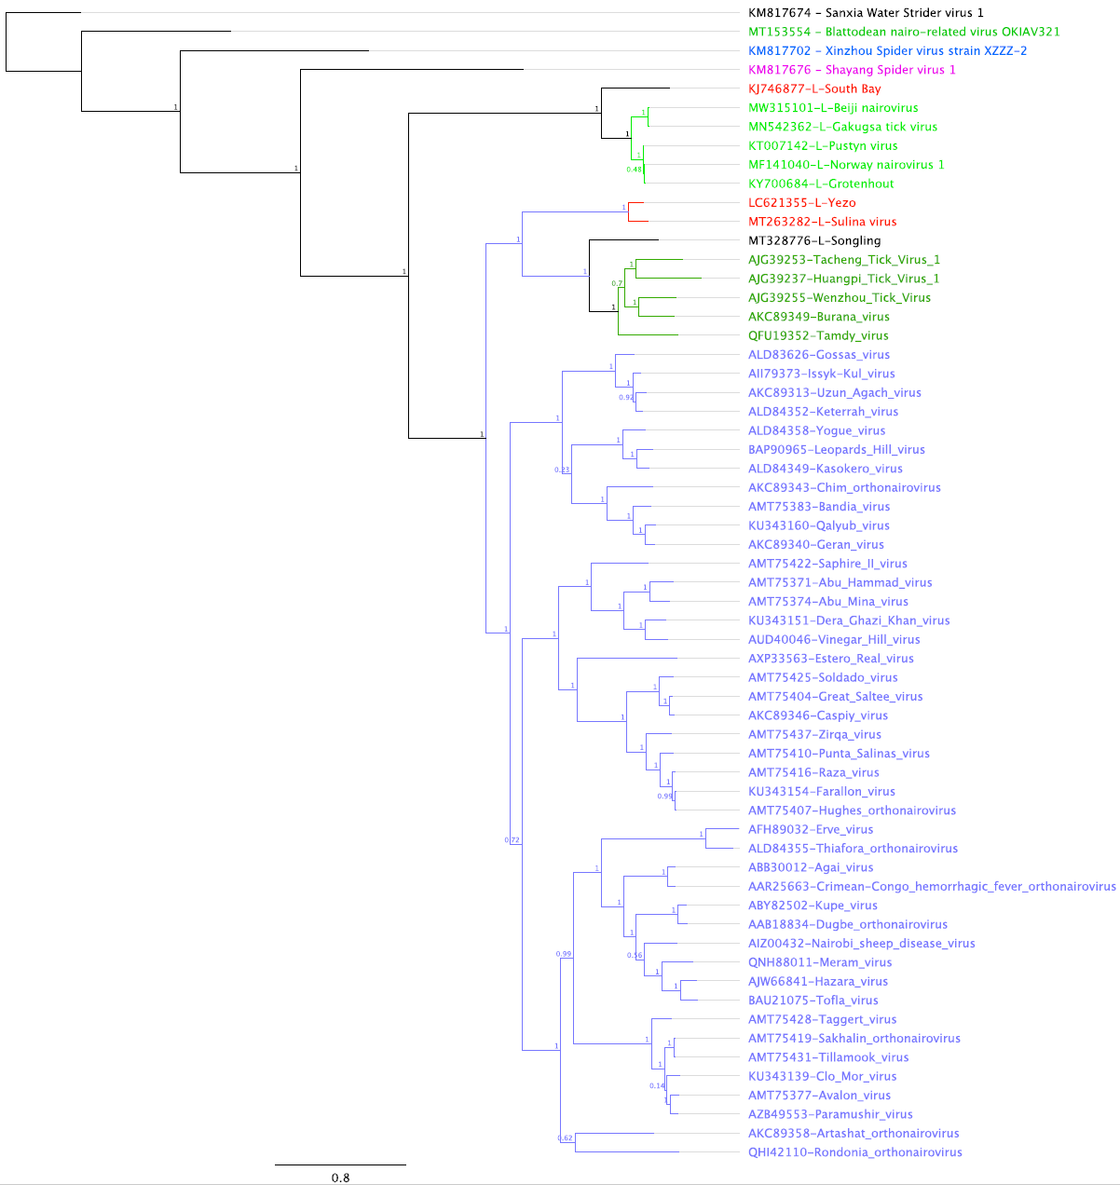

Figure 1. The maximum-likelihood phylogenetic tree was inferred using IQtree [5]; the numbers on the nodes represent bootstrap values derived from the ultrafast bootstrap algorithm [1]. Trees were inferred under the LG+G+I substitution model. Tree branches are proportional to genetic distances between sequences, and the scale bars at the top indicate substitutions per amino acid. For all taxa shown here, the complete genome or complete coding sequence is available on the GenBank nucleotide sequence database. Accession numbers are shown next to the respective virus taxon.

References
1. Hoang DT, Chernomor O, von Haeseler A, Minh BQ, Vinh LS (2018) UFBoot2: improving the ultrafast bootstrap approximation. Mol Biol Evol 35:518-522. PMID: 29077904. PMCID: PMC5850222. doi: 10.1093/molbev/msx281.
2. Kodama F, Yamaguchi H, Park E, Tatemoto K, Sashika M, Nakao R, Terauchi Y, Mizuma K, Orba Y, Kariwa H, Hagiwara K, Okazaki K, Goto A, Komagome R, Miyoshi M, Ito T, Yamano K, Yoshii K, Funaki C, Ishizuka M, Shigeno A, Itakura Y, Bell-Sakyi L, Edagawa S, Nagasaka A, Sakoda Y, Sawa H, Maeda K, Saijo M, Matsuno K (2021) A novel nairovirus associated with acute febrile illness in Hokkaido, Japan. Nat Commun 12:5539. PMID: 34545081. PMCID: PMC8452618. doi: 10.1038/s41467-021-25857-0.
3. Ma J, Lv XL, Zhang X, Han SZ, Wang ZD, Li L, Sun HT, Ma LX, Cheng ZL, Shao JW, Chen C, Zhao YH, Sui L, Liu LN, Qian J, Wang W, Liu Q (2021) Identification of a new orthonairovirus associated with human febrile illness in China. Nat Med 27:434-439. PMID: 33603240. doi: 10.1038/s41591-020-01228-y.
4. Meng F, Ding M, Tan Z, Zhao Z, Xu L, Wu J, He B, Tu C (2019) Virome analysis of tick-borne viruses in Heilongjiang Province, China. Ticks Tick Borne Dis 10:412-420. PMID: 30583876. doi: 10.1016/j.ttbdis.2018.12.002.
5. Nguyen LT, Schmidt HA, von Haeseler A, Minh BQ (2015) IQ-TREE: a fast and effective stochastic algorithm for estimating maximum-likelihood phylogenies. Mol Biol Evol 32:268-74. PMID: 25371430. PMCID: PMC4271533. doi: 10.1093/molbev/msu300.
6. Pettersson JH, Shi M, Bohlin J, Eldholm V, Brynildsrud OB, Paulsen KM, Andreassen Å, Holmes EC (2017) Characterizing the virome of Ixodes ricinus ticks from northern Europe. Sci Rep 7:10870. PMID: 28883464. PMCID: PMC5589870. doi: 10.1038/s41598-017-11439-y.
7. Tomazatos A, von Possel R, Pekarek N, Holm T, Rieger T, Baum H, Bialonski A, Maranda I, Erdelyi-Molnár I, Spînu M, Lühken R, Jansen S, Emmerich P, Schmidt-Chanasit J, Cadar D (2021) Discovery and genetic characterization of a novel orthonairovirus in Ixodes ricinus ticks from Danube Delta. Infect Genet Evol 88:104704. PMID: 33418146. doi: 10.1016/j.meegid.2021.104704.

