Part 1: TITLE, AUTHORS, APPROVALS, etc

Code assigned: | 2022.009D
Short title: Establishing 48 new species and renaming 101 species in the family Circoviridae

Author(s) and email address(es)
Varsani A, Harrach B, Roumagnac P, Benkő M, Breitbart M, Delwart E, Franzo G, Kazlauskas D, Rosario K, Segalés J, Krupovic M | Arvind.varsani@asu.edu; balazs.harrach@gmail.com; philippe.roumagnac@cirad.fr; maribenko@gmail.com; mya@usf.edu; delwarte@medicine.ucsf.edu; giovanni.franzo@unipd.it; dariausk@gmail.com; krosari2@mail.usf.edu; joaquim.segales@uab.cat; mart.krupovic@pasteur.fr
Author(s) institutional address(es) (optional)
The Biodesign Center for Fundamental and Applied Microbiomics, Center for Evolution and Medicine, School of Life sciences, Arizona State University, Tempe, AZ 85287-5001, USA [AV]
Veterinary Medical Research Institute, Budapest 1143, Hungary [BH, MB]
CIRAD - UMR PHIM, Campus International de Baillarguet, 34398 Montpellier, France [PR]
College of Marine Science, University of South Florida, Saint Petersburg, FL 33701, USA [KR, MB]
Department of Laboratory Medicine, University of California San Francisco, San Francisco, CA 94118, USA [ED]
Dipartimento di Medicina Animale, Produzione e Salute, Università di Padova, Viale dell’Università 16, 35020 Legnaro, Italy [GF]
Institute of Biotechnology, Life Sciences Center, Vilnius University, Saulėtekio av. 7, Vilnius 10257, Lithuania [DK]
UAB, Centre de Recerca en Sanitat Animal (CReSA, IRTAUAB), Campus de la Universitat Autònoma de Barcelona, Bellaterra, 08193 Barcelona, Spain [JS]
Institut Pasteur, Université Paris Cité, CNRS UMR6047, Archaeal Virology Unit, 25 rue du Dr Roux, 75015 Paris, France [MK]

Corresponding author
Arvind Varsani

List the ICTV Study Group(s) that have seen this proposal
Circoviridae Study Group

ICTV Study Group comments and response of proposer
All who responded in agreement including a non-study group member (Roumagnac P) who is a author on this TP.

ICTV Study Group votes on proposal
Study Group | Number of members
 | Votes support | Votes against | No vote
Circoviridae Study Group | 8 | 0 | 2
Authority to use the name of a living person
Is any taxon name used here derived from that of a living person (Y/N)

Taxon name | Person from whom the name is derived | Permission attached (Y/N)

Submission dates
Date first submitted to SC Chair | 25 May 2022
Date of this revision (if different to above)
ICTV-EC comments and response of the proposer

Part 2: NON-TAXONOMIC PROPOSAL
Text of proposal

Part 3: TAXONOMIC PROPOSAL
Name of accompanying Excel module
2022.009D.N.v2Circoviridae_101rensp_48nsp.xlsx
Abstract
Circoviruses are small viruses with circular single-stranded DNA genomes that are classified within two genera, Circovirus and Cyclovirus, in the family Circoviridae (phylum Cressdnaviricota, class Arfiviricetes, order Circlivirales). During the last two years, a number of new circoviruses have been identified and 48 new species need to be established for their classification. The classification is based on the guidelines set forward, i.e., 80% genome-wide pairwise identity species threshold for member of the family Circoviridae. Further, we rename 101 currently established species to binomial format with a freeform epithet.
Text of proposal
In the family Circoviridae (phylum Cressdnaviricota, class Arfiviricetes order Circlivirales), there are two established genera, Circovirus and Cyclovirus. Viruses within these two genera are classified into species based on genome-wide pairwise identities with 80% species demarcation threshold [1].

Over the last two years, a significant number of circovirus genomes have been identified from various organisms or their fecal samples. Based on the analysis of the genome-wide pairwise identities coupled with phylogenetic support, we propose the creation of 48 new species (11 in the genus Circovirus and 37 in the genus Cyclovirus) to classify these new circoviruses (summarized in Table 1). The proposed classification is also supported by phylogenetic analysis of the genome nucleotide sequences as well as analysis of the pairwise nucleotide sequence identities (Figure 1-4).

With an aim to comply with the mandated binomial species naming format [2], we have renamed the current species (n=101) in the family Circoviridae using binomial nomenclature with a freeform epithet. All epithets are either derivatives of host species or isolation source using names in different languages of peoples that inhabit that region where possible (Table 1). In cases where hosts are known and the viruses were experimentally studied, in order to have minimal disruption, we have used common names for the hosts. In the case of the species Porcine circovirus 1, Porcine circovirus 2, Porcine circovirus 3 and Porcine circovirus 4 we have additionally used an alphanumeric epithet to name them as Circovirus porcine1, Circovirus porcine2, Circovirus porcine3 and Circovirus porcine4. Notes on species naming are provided in Table 2.

Supporting evidence

Table 1: Summary of the taxonomy of currently classified circoviruses with new binomial species names provided in blue font.
Accession | Virus name | Host /source | Country | Current species | New species name | Epithet notes
GU799606 | barbel circovirus | Barbus barbus | Hungary | Barbel circovirus | Circovirus barbel | common name for host
JX863737 | bat associated circovirus 1 | Rhinolophus ferrumequinum | Myanmar | Bat associated circovirus 1 | Circovirus chauvesouris | bat in French (2 words)
KC339249 | bat associated circovirus 2 | Rhinolophus ferrumequinum | Myanmar | Bat associated circovirus 2 | Circovirus vleermuis | bat in Dutch
JQ814849 | Rhinolophus ferrumequinum circovirus 1 | Rhinolophus ferrumequinum | China | Bat associated circovirus 3 | Circovirus bianfu | bat in Chinese
KT783484 | Tadarida brasiliensis circovirus 1 | Tadarida brasiliensis | Brazil | Bat associated circovirus 4 | Circovirus bastao | bat in Portuguese
KJ641727 | bat associated circovirus 5 | Plecotus auritus | China | Bat associated circovirus 5 | Circovirus saguzarra | bat in Basque
KJ641724 | bat associated circovirus 6 | Rhinolophus affinis | China | Bat associated circovirus 6 | Circovirus ratpenat | bat in Catalan
KJ641723 | bat associated circovirus 7 | Rhinolophus sinicus | China | Bat associated circovirus 7 | Circovirus lepakko | bat in Finnish
KJ641711 | bat associated circovirus 8 | Myotis ricketti | China | Bat associated circovirus 8 | Circovirus morcego | bat in Galician
KJ641741 | bat associated circovirus 9 | Rhinolophus ferrumequinum | China | Bat associated circovirus 9 | Circovirus kelawar | bat in Malay
KX756986 | bat circovirus Acheng30 | Vespertilio sinensis | China | Bat associated circovirus 10 | Circovirus ialtag | bat in Scottish
KX756996 | bat circovirus Mengyuan2 | Hipposideros armiger | China | Bat associated circovirus 11 | Circovirus siksparnis | bat in Latvian
KJ641716 | bat circovirus CV/GD2012 | Pipistrellus sp. | China | Bat associated circovirus 12 | Circovirus cia | bat in Lao
MN928506 | bat circovirus Sardinia | Miniopterus schreibersii | Italy | Bat associated circovirus 13 | Circovirus pipistrello | bat in Italian
AF071878 | beak and feather disease virus | Psittaciformes species | USA | Beak and feather disease virus | Circovirus parrot | common name for host
MN371255 | Ursus americanus circovirus | Ursus americanus americanus | USA | Bear circovirus | Circovirus bear | common name for host
AJ301633 | canary circovirus | Serinus canaria | Italy | Canary circovirus | Circovirus canary | common name for host
KC241982 | canine circovirus | Canis lupus familiaris | USA | Canine circovirus | Circovirus canine | common name for host
GQ404851 | chimpanzee stool avian-like circovirus | Pan troglodytes | Rwanda | Chimpanzee associated circovirus 1 | Circovirus impundu | chimpanzee in Kinyarwanda
LC416389 | Paguma larvata circovirus | Paguma larvata | Japan | Civet circovirus | Circovirus civet | common name for host
AY228555 | mulard duck circovirus | Anas domesticus | USA | Duck circovirus | Circovirus duck | common name for host
MN585201 | elk circovirus | Cervus canadensis | Canada | Elk circovirus | Circovirus elk | common name for host
JQ011377 | Silurus glanis circovirus | Silurus glanis | Hungary | European catfish circovirus | Circovirus catfish | common name for host
DQ845075 | finch circovirus | Chloebia gouldiae |  | Finch circovirus | Circovirus finch | common name for host
AJ304456 | goose circovirus | Goose | Germany | Goose circovirus | Circovirus goose | common name for host
DQ845074 | gull circovirus | Larus argentatus | Sweden | Gull circovirus | Circovirus gull | common name for host
GQ404856 | human stool-associated circular virus | Homo sapiens | Nigeria | Human associated circovirus 1 | Circovirus eniyan | human in Yoruba
KJ020099 | mink circovirus | Mustela sp. | China | Mink circovirus | Circovirus mink | common name for host
MH188038 | Culex circovirus-like virus | Culex sp. | USA | Mosquito associated circovirus 1 | Circovirus mossi | common word for mosquito in USA
MN164703 | penguin circovirus | Pygoscelis adeliae | Antarctica | Penguin circovirus | Circovirus penguin | common name for host
AF252610 | Columbid circovirus | Columbia livia | Germany | Pigeon circovirus | Circovirus pigeon | common name for host
AF071879 | porcine circovirus 1 | Sus scrofa domesticus |  | Porcine circovirus 1 | Circovirus porcine1 | common name for host
AY651850 | porcine circovirus 2 | Sus scrofa domesticus | Canada | Porcine circovirus 2 | Circovirus porcine2 | common name for host
KT869077 | porcine circovirus 3 | Sus scrofa domesticus | USA | Porcine circovirus 3 | Circovirus porcine3 | common name for host
MK986820 | porcine circovirus 4 | Sus scrofa domesticus | China | Porcine circovirus 4 | Circovirus porcine4 | common name for host
DQ146997 | raven circovirus | Corvus coronoides | Australia | Raven circovirus | Circovirus raven | common name for host
KY370034 | rodent circovirus 1 | Neodon clarkei | China | Rodent associated circovirus 1 | Circovirus rongeur | rodent in French
KY370042 | rodent circovirus 2 | Apodemus chevrieri | China | Rodent associated circovirus 2 | Circovirus kiore | rodent in Māori
KY370039 | rodent circovirus 3 | Neodon clarkei | China | Rodent associated circovirus 3 | Circovirus roditore | rodent in Italian
KY370029 | rodent circovirus 4 | Allactaga sibirica | China | Rodent associated circovirus 4 | Circovirus rosegador | rodent in Catalan
KY370027 | rodent circovirus 5 | Niviventer eha | China | Rodent associated circovirus 5 | Circovirus gnaver | rodent in Danish
KY370037 | rodent circovirus 6 | Apodemus draco | China | Rodent associated circovirus 6 | Circovirus daga | rodent in Filipino
MF497827 | bamboo rat circovirus | Rhizomys pruinosus | China | Rodent associated circovirus 7 | Circovirus gryzon | rodent in Polish
DQ172906 | starling circovirus | Sturnus vulgaris | Spain | Starling circovirus | Circovirus starling | common name for host
EU056309 | Cygnus olor circovirus | Cygnus olor | Germany | Swan circovirus | Circovirus swan | common name for host
KU230452 | avian-like circovirus | Ixodes scapulari | USA | Tick associated circovirus 1 | Circovirus yaa | tick in Navajo
KX987146 | tick circovirus 2 | Ixodes crenulatus | China | Tick associated circovirus 2 | Circovirus pichong | tick in Chines (two words Pí chóng)
MN103538 | beaked whale circovirus | Indopacetus pacificus | USA | Whale circovirus | Circovirus whale | common name for host
KP793918 | zebra finch circovirus | Taeniopygia guttata | Germany | Zebra finch circovirus | Circovirus zebrafinch | common name for host
MH545511 | arboreal ant associated circular virus 1 | Crematogaster nigriceps | Kenya | Ant associated cyclovirus 1 | Cyclovirus mchwa | Ant in Swahili
HM228874 | bat cyclovirus GF-4c | Antrozous pallidus | USA | Bat associated cyclovirus 1 | Cyclovirus jaaabani | bat in Navajo
JF938079 | bat associated cyclovirus 2 | Myotis spp. | China | Bat associated cyclovirus 2 | Cyclovirus jemage | bat in Hausa
JF938081 | bat associated cyclovirus 3 | Myotis spp. | China | Bat associated cyclovirus 3 | Cyclovirus kiroptero | bat in Esperanto
JF938082 | bat associated cyclovirus 4 | Myotis spp. | China | Bat associated cyclovirus 4 | Cyclovirus sismis | bat is Croatian
HQ738637 | cyclovirus bat CyCV-TB | Tadarida brasiliensis | USA | Bat associated cyclovirus 5 | Cyclovirus flagermus | bat in Danish
KJ641712 | bat associated cyclovirus 6 | Rhinolophus pusillus | China | Bat associated cyclovirus 6 | Cyclovirus popo | bat in Swahili
KJ641740 | bat associated cyclovirus 7 | Rhinolophus pusillus | China | Bat associated cyclovirus 7 | Cyclovirus liliac | bat in Romanian
KJ641715 | bat associated cyclovirus 8 | Rhinolophus pusillus | China | Bat associated cyclovirus 8 | Cyclovirus nahkhiir | bat in Estonian
KJ641720 | bat associated cyclovirus 9 | Tylonycteris pachypus | China | Bat associated cyclovirus 9 | Cyclovirus khangkhaw | bat in Norwegian
KM382270 | Bat circovirus POA/2012/VI | Molossus molossus,Tadarida brasiliensis | Brazil | Bat associated cyclovirus 10 | Cyclovirus bastao | bat in Portuguese
KJ641717 | bat associated cyclovirus 11 | Myotis spp. | China | Bat associated cyclovirus 11 | Cyclovirus yarasa | bat in Uzbek
KM382269 | bat circovirus POA/2012/II | Molossus molossus,Tadarida brasiliensis | Brazil | Bat associated cyclovirus 12 | Cyclovirus doi | bat in Vietnamese (originally two words)
KJ641728 | bat associated cyclovirus 13 | Plecotus auritus | China | Bat associated cyclovirus 13 | Cyclovirus nietoperz | bat in Polish
KT732785 | Pacific flying fox associated cyclovirus-1 | Pteropus tonganus | Tonga | Bat associated cyclovirus 14 | Cyclovirus peka | bat in Tongan
KT732786 | Pacific flying fox associated cyclovirus-2 | Pteropus tonganus | Tonga | Bat associated cyclovirus 15 | Cyclovirus pea | bat in Samoan
KT732787 | Pacific flying fox associated cyclovirus-3 | Pteropus tonganus | Tonga | Bat associated cyclovirus 16 | Cyclovirus pekapeka | bat in Māori
HQ738634 | cyclovirus PKbeef23/PAK/2009 | Bos taurus | Pakistan | Bovine associated cyclovirus 1 | Cyclovirus gaaye | cow in Urdu
MK947371 | capybara associated cyclovirus 1 | Hydrochoerus hydrochaeris | Brazil | Capybara associated cyclovirus | Cyclovirus roedor | rodent in Portuguese
HQ738643 | cyclovirus NGchicken8/NGA/2009 | Gallus gallus | Nigeria | Chicken associated cyclovirus 1 | Cyclovirus adie | chicken in Yoruba
MG846358 | chicken associated cyclovirus 2 | Gallus gallus | USA | Chicken associated cyclovirus 2 | Cyclovirus naahoohai | chicken in Navajo
GQ404849 | Cyclovirus Chimp11 | Pan troglodytes | Central Africa | Chimpanzee associated cyclovirus 1 | Cyclovirus sokwe | chimpanzee in Swahili
JX569794 | Florida woods cockroach cyclovirus | Eurycotis floridana | USA | Cockroach associated cyclovirus 1 | Cyclovirus roach | common name for cockroach in USA
JX185419 | dragonfly cyclovirus 1 | Pantala flavescens | Tonga | Dragonfly associated cyclovirus 1 | Cyclovirus kisikisi | dragonfly in Tongan
JX185422 | dragonfly cyclovirus 2 | Pantala flavescens | USA | Dragonfly associated cyclovirus 2 | Cyclovirus taniilai | dragonfly in Navajo
JX185424 | dragonfly cyclovirus 3 | Erythemis simplicicollis | USA | Dragonfly associated cyclovirus 3 | Cyclovirus tonbo | dragonfly in Japanese
KC512916 | dragonfly cyclovirus 4 | Aeshna multicolor | USA | Dragonfly associated cyclovirus 4 | Cyclovirus vazka | dragonfly in Slovakian
JX185426 | dragonfly cyclovirus 5 | Erythrodiplax umbrata | Puerto Rico | Dragonfly associated cyclovirus 5 | Cyclovirus libelula | dragonfly in Spanish
KC512918 | dragonfly cyclovirus 6 | Aeshna multicolor | USA | Dragonfly associated cyclovirus 6 | Cyclovirus babka | dragonfly in Ukrainian
KC512919 | dragonfly cyclovirus 7 | Xanthocnemis zealandica | New Zealand | Dragonfly associated cyclovirus 7 | Cyclovirus namu | dragonfly in Māori
KC512920 | dragonfly cyclovirus 8 | Orthetrum Sabina | Australia | Dragonfly associated cyclovirus 8 | Cyclovirus tarako | dragonfly in Samoan
KY851116 | duck associated cyclovirus 1 | Anas platyrhynchos | Hungary | Duck associated cyclovirus 1 | Cyclovirus kacsa | duck in Hungarian
KM017740 | feline cyclovirus | Felis catus | USA | Feline associated cyclovirus 1 | Cyclovirus gato | cat in Spanish
HQ738636 | cyclovirus PKgoat11/PAK/2009 | Capra aegagrus hircus | Pakistan | Goat associated cyclovirus 1 | Cyclovirus bakri | goat in Urdu
KR902499 | cyclovirus Equ1 | Equus caballus | USA | Horse associated cyclovirus 1 | Cyclovirus caballo | horse in Spanish
GQ404847 | cyclovirus PK5510 | Homo sapiens | Pakistan | Human associated cyclovirus 1 | Cyclovirus maanav | human in Hindi
GQ404844 | cyclovirus PK500 | Homo sapiens | Pakistan | Human associated cyclovirus 2 | Cyclovirus insaan | human in Urdu
GQ404846 | cyclovirus PK5222 | Homo sapiens | Pakistan | Human associated cyclovirus 3 | Cyclovirus manukha | human in Punjabi
GQ404857 | cyclovirus TN25 | Homo sapiens | Tunisia | Human associated cyclovirus 4 | Cyclovirus bashri | human in Arabic
GQ404845 | cyclovirus PK5034 | Homo sapiens | Pakistan | Human associated cyclovirus 5 | Cyclovirus homa | human in Esperanto
GQ404854 | cyclovirus NG12 | Homo sapiens | Nigeria | Human associated cyclovirus 6 | Cyclovirus mmadu | human in Igbo
GQ404855 | cyclovirus NG14 | Homo sapiens | Nigeria | Human associated cyclovirus 7 | Cyclovirus mutum | human in Hausa
KF031466 | cyclovirus VN | Homo sapiens | Vietnam | Human associated cyclovirus 8 | Cyclovirus nhanloai | human in Vietnamese
KC771281 | Human cyclovirus VS5700009 | Homo sapiens | Malawi | Human associated cyclovirus 9 | Cyclovirus munthu | human in Chichewa
KF726984 | human associated cyclovirus 10 | Homo sapiens | Chile | Human associated cyclovirus 10 | Cyclovirus humana | human in Spanish
KJ831064 | cyclovirus SL-108277 | Homo sapiens | Sri Lanka | Human associated cyclovirus 11 | Cyclovirus manitan | human in Tamil
KU053483 | Indian encephalitis associated cyclovirus | Homo sapiens | India | Human associated cyclovirus 12 | Cyclovirus manusyan | human in Malayalam
KT878836 | mouse associated cyclovirus 1 | mouse | USA | Mouse associated cyclovirus 1 | Cyclovirus naastsosi | small rodent in Navajo
KY370028 | rodent associated cyclovirus 1 | Rattus flavipectus | China | Rodent associated cyclovirus 1 | Cyclovirus rata | rat in Galician
KY370026 | rodent associated cyclovirus 2 | Rattus tanezumi sladeni | China | Rodent associated cyclovirus 2 | Cyclovirus podgana | rat in Slovenian
MH545516 | soft spider associated circular virus 1 | Cybaeidae | Canada | Spider associated cyclovirus 1 | Cyclovirus aasiak | spider in Inuktitut
LC018134 | cyclovirus TsCyV-1 | Callosciurus erythraeus thaiwanensis | Japan | Squirrel associated cyclovirus 1 | Cyclovirus risi | squirrel in Japanese

Table 2: Summary of the taxonomy of new proposed species in the family Circoviridae. Binomial species names are in blue font.
Accession | Virus name | host /source | Country | Species name | Epithet notes
MN164712 | werosea circovirus | Leptonychotes weddellii | Antarctica | Circovirus tetning | seal in Norwegian
MT610105 | sonfela circovirus 1 | Lynx rufus | Mexico | Circovirus miztli | Mountain lion in Nahuatl
MT610106 | sonfela circovirus 2 | Lynx rufus | Mexico | Circovirus miztontli | cat in Milpa Alta
MW686208 | wolvfec circovius | Gulo gulo | USA | Circovirus gloton | wolverine in Spanish
MW881235 | equine circovirus 1 | Equus ferus caballus | USA | Circovirus lin | horse in Navajo
MZ382570 | Mongoose-associated circovirus Mon-1 | Urva auropunctata | Saint Kitts and Nevis | Circovirus magu | mongoose in Punjabi
MZ604582 | wigfec circovirus 1 | Mareca americana | USA | Circovirus naaleeli | waterfowl in Navajo
MZ604590 | wigfec circovirus 2 | Mareca americana | USA | Circovirus pato | waterfowl in Spanish
OL704833 | Eumops bonariensis associated circovirus 1 | Eumops bonariensis | Argentina | Circovirus tzinaka | bat in Nahuatl
OM869597 | dipodfec virus UA04Rod_4537 | Dipodomys merriami feces | USA | Circovirus hirat | rat in Volapuk
ON596197 | calfel virus LSF45_cir359 | Lynx rufus | USA | Circovirus wesa | cat in Cherokee
MN176052 | werosea cyclovirus | Leptonychotes weddellii | Antarctica | Cyclovirus foca | seal in Galician
MT707947 | Caesalpinia ferrea associated virus | Libidibia ferrea | Brazil | Cyclovirus pauferro | common word for this tree in Brazil - (pau ferro)
MT766309 | bat associated cyclovirus Cg1 | Chalinolobus gouldii | Australia | Cyclovirus vauval | bat in Tamil
MT766312 | bat associated cyclovirus Vr1 | Eptesicus regulus | Australia | Cyclovirus netopyr | bat in Czech
MZ350964 | robinz virus RP_259 | Petroica australis | New Zealand | Cyclovirus totoi | robin in Māori
MZ350965 | robinz virus RP_493 | Petroica australis | New Zealand | Cyclovirus pettirosso | robin in Italian
MZ350966 | robinz virus RP_526 | Petroica australis | New Zealand | Cyclovirus punarinta | robin in Finnish
MZ350967 | robinz virus RP_584 | Petroica australis | New Zealand | Cyclovirus rudzik | robin in Polish
MZ350968 | robinz virus RP_620 | Petroica australis | New Zealand | Cyclovirus prihor | robin in Romanian
MZ350969 | robinz virus RP_736 | Petroica australis | New Zealand | Cyclovirus cervienka | robin in Slovak
MZ350973 | robinz virus RP_1170 | Petroica australis | New Zealand | Cyclovirus liepsnele | robin in Lithuanian
MZ382572 | mongoose-associated cyclovirus Mon-32 | Urva auropunctata | Saint Kitts and Nevis | Cyclovirus newla | small Indian mongoose in Hindi
MZ382573 | mongoose-associated cyclovirus Mon-20 | Urva auropunctata | Saint Kitts and Nevis | Cyclovirus mweyba | small Indian mongoose in Burmese
OL704826 | bat associated cyclovirus 17 | Molossus molossus | Argentina | Cyclovirus murcielago | bat in Spanish
OL704827 | Tadarida brasiliensis associated cyclovirus 1 | Tadarida brasiliensis | Argentina | Cyclovirus vespertilio | bat in Latin
OL704828 | Eumops bonariensis associated cyclovirus 1 | Eumops bonariensis | Argentina | Cyclovirus muricec | bat in Catalan
OM262451 | chifec virus UA13_1727 | Tadarida brasiliensis | USA | Cyclovirus saguza | bat in Basque
OM262452 | chifec virus UA13_1817 | Tadarida brasiliensis | USA | Cyclovirus sawya | bat in Hopi
OM262453 | chifec virus UA15_35 | Lasionycteris noctivagans | USA | Cyclovirus prilep | bat in Bulgarian
OM262456 | chifec virus UA13_1880 | Tadarida brasiliensis | USA | Cyclovirus fledermoyz | bat in Yiddish
OM262457 | chifec virus UA13_1887 | Tadarida brasiliensis | USA | Cyclovirus vleermuis | bat in Dutch
OM262458 | chifec virus UA13_1800 | Tadarida brasiliensis | USA | Cyclovirus ystlum | bat in Welsh
OM262459 | chifec virus UA15_2320 | Lasionycteris noctivagans | USA | Cyclovirus liljak | bat in Macedonian
OM869595 | dipodfec virus UA04Rod_5913 | Dipodomys merriami | USA | Cyclovirus rotte | rat in Danish
OM869613 | dipodfec virus UA23Rod_1805 | Dipodomys spectabilis | USA | Cyclovirus kemirgen | rodent in Turkish
ON324066 | Army ant associated cyclovirus 3 P1A-reste_4 | Dorylus sp. | Gabon | Cyclovirus ibimonyo | ant in Kinyarwanda
ON324069 | army ant associated cyclovirus 6 P16-reste_1 | Dorylus sp. | Gabon | Cyclovirus fourmi | ant in French
ON324071 | army ant associated cyclovirus 2 P8A-4.2_2 | Dorylus sp. | Gabon | Cyclovirus anyidiwo | ant in Ewe
ON324100 | army ant associated cyclovirus 1 P21/23-reste_1 | Dorylus sp. | Gabon | Cyclovirus kokoro | ant in Yoruba
ON324103 | army ant associated cyclovirus 4 P8A-3.2_1 | Dorylus sp. | Gabon | Cyclovirus mier | ant in Dutch
ON324104 | army ant associated cyclovirus 5 170_4 | Dorylus sp. | Gabon | Cyclovirus bohloa | ant in Sesotho
ON324106 | army ant associated cyclovirus 7 P4A-reste_1 | Dorylus sp. | Gabon | Cyclovirus svosve | ant in Shona
ON324107 | army ant associated cyclovirus 8 P1A-reste_2 | Dorylus sp. | Gabon | Cyclovirus enseenene | ant in Luganda
ON324108 | army ant associated cyclovirus 9 183_1 | Dorylus sp. | Gabon | Cyclovirus ndanda | ant in Igbo
ON596192 | calfel virus LSF17_cyc102 | Lynx rufus | USA | Cyclovirus popoki | cat in Hawaiian
ON596195 | calfel virus LSF31_cyc420 | Lynx rufus | USA | Cyclovirus misi | cat in Quechua
ON596196 | calfel virus LSF31_cyc880 | Lynx rufus | USA | Cyclovirus moosa | cat in Hopi

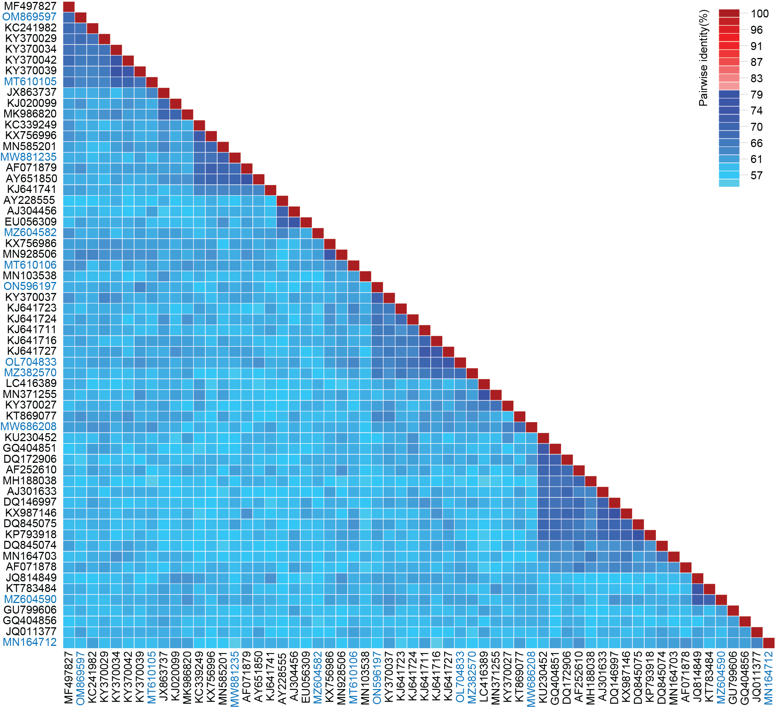
Figure 1: A ‘two color’ pairwise identity matrix of representative genome-wide comparisons among sequences in the genus Circovirus inferred using SDT v1.2 [3]. Representative sequences from the proposed new species (n=11) are highlighted in blue font.

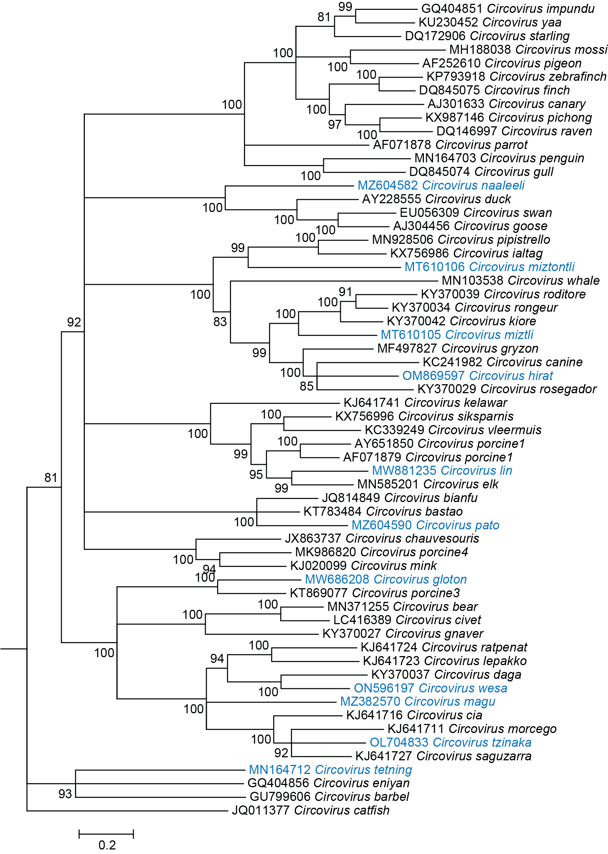
Figure 2: Maximum likelihood phylogenetic tree (rooted with reverse complement sequences of cycloviruses) of representative genomes from each circovirus species (aligned with MAFFT v7 [4]) inferred using PHYML [5] with GTR+I+G4 chosen as the best fit model. Branches with <0.8 aLRT (approximate likelihood ratio test) branch support have been collapsed with TreeGraph2 [6].

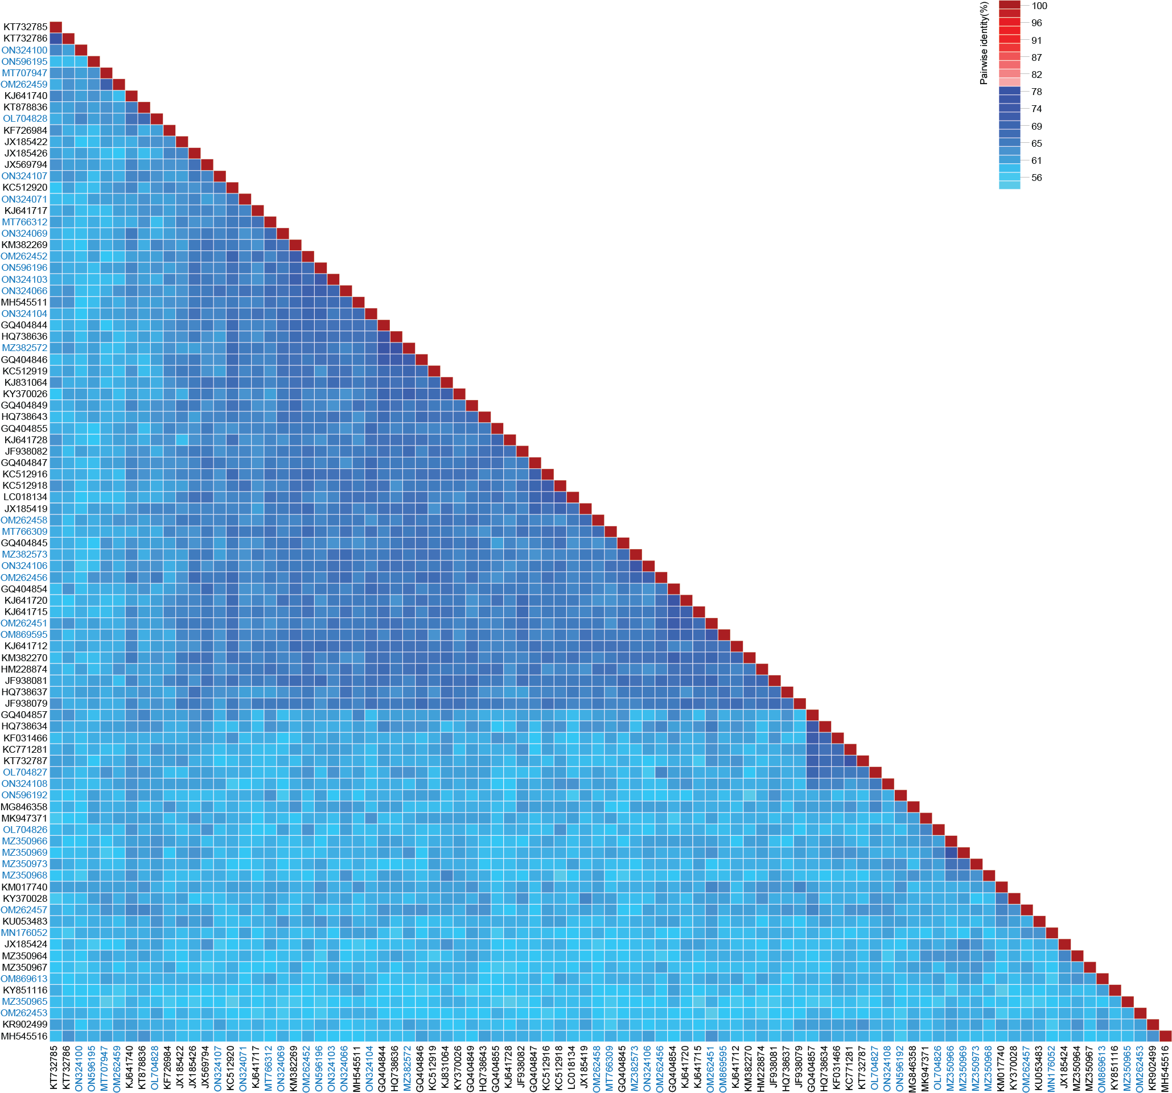
Figure 3: A ‘two color’ pairwise identity matrix of representative genome-wide comparisons among sequences in the genus Cyclovirus inferred using SDT v1.2 [3]. Representative sequences from the proposed new species (n=37) are highlighted in blue font.
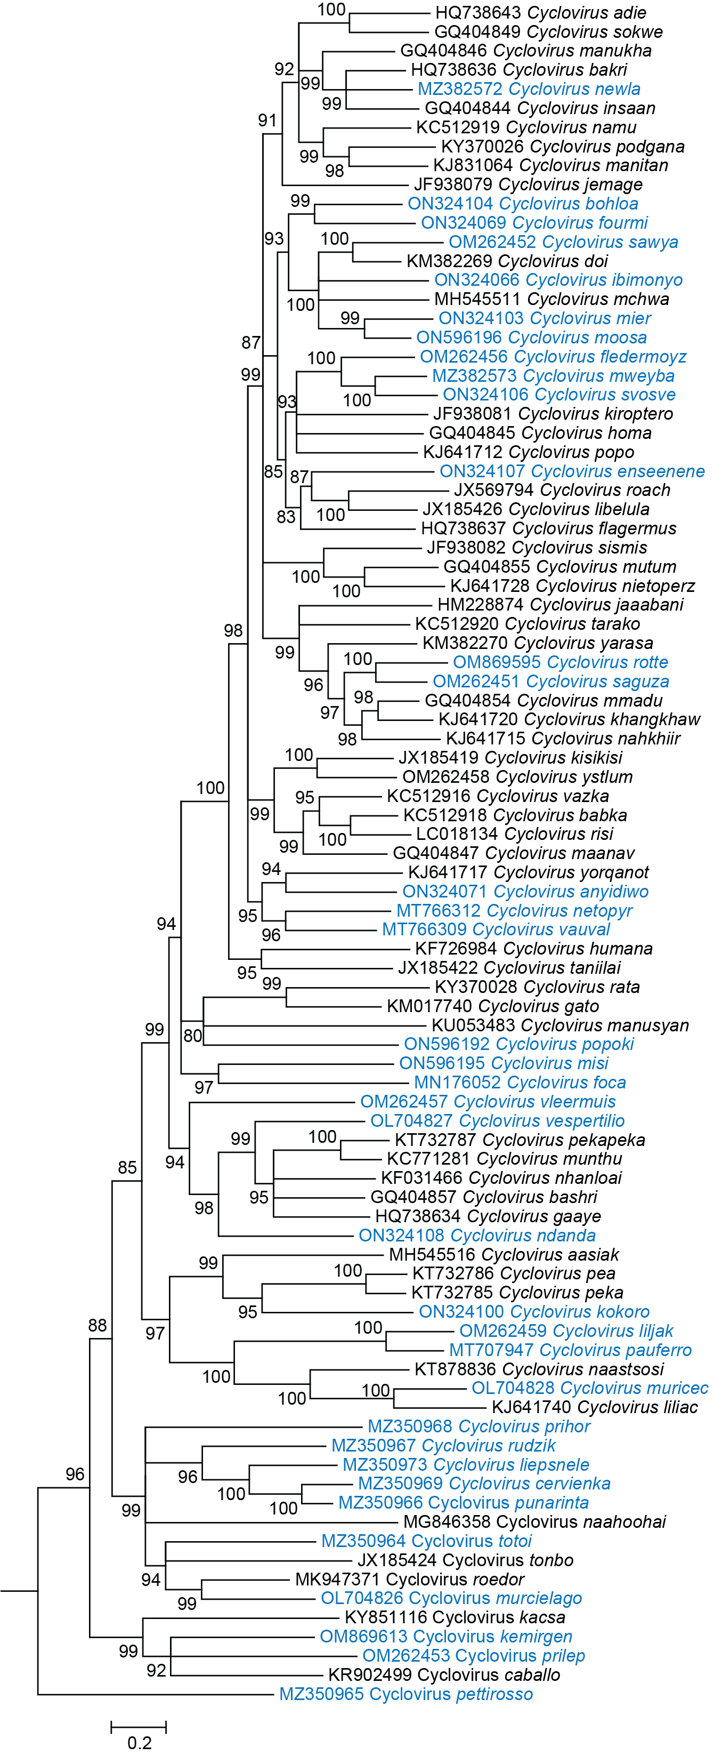
Figure 4: Maximum likelihood phylogenetic tree (rooted with reverse complement sequences of circoviruses) of representative genomes from each cyclovirus species (aligned with MAFFT v7 [4]) inferred using PHYML [5] with GTR+I+G4 chosen as the best fit model. Branches with <0.8 aLRT (approximate likelihood ratio test) branch support have been collapsed with TreeGraph2 [6].
References

- Rosario K, Breitbart M, Harrach B, Segales J, Delwart E, Biagini P, Varsani A (2017) Revisiting the taxonomy of the family Circoviridae: establishment of the genus Cyclovirus and removal of the genus Gyrovirus. Arch Virol 162:1447-1463. PMID: 28155197; DOI: 10.1007/s00705-017-3247-y
- Siddell SG, Walker PJ, Lefkowitz EJ, Mushegian AR, Dutilh BE, Harrach B, Harrison RL, Junglen S, Knowles NJ, Kropinski AM, Krupovic M, Kuhn JH, Nibert ML, Rubino L, Sabanadzovic S, Simmonds P, Varsani A, Zerbini FM, Davison AJ (2020) Binomial nomenclature for virus species: a consultation. Arch Virol 165:519-525. PMID: 31797129; DOI: 10.1007/s00705-019-04477-6
- Muhire BM, Varsani A, Martin DP (2014) SDT: a virus classification tool based on pairwise sequence alignment and identity calculation. PLoS One 9:e108277. PMID: 25259891; DOI: 10.1371/journal.pone.0108277
- Katoh K, Rozewicki J, Yamada KD (2019) MAFFT online service: multiple sequence alignment, interactive sequence choice and visualization. Brief Bioinform 20:1160-1166. PMID: 28968734; DOI: 10.1093/bib/bbx108
- Guindon S, Dufayard JF, Lefort V, Anisimova M, Hordijk W, Gascuel O (2010) New algorithms and methods to estimate maximum-likelihood phylogenies: assessing the performance of PhyML 3.0. Syst Biol 59:307-321. PMID: 20525638; DOI: 10.1093/sysbio/syq010
- Stover BC, Muller KF (2010) TreeGraph 2: combining and visualizing evidence from different phylogenetic analyses. BMC Bioinformatics 11:7. PMID: 20051126; DOI: 10.1186/1471-2105-11-7

